1. The photograph shows an animal called a margay. Four processes that occur in the margay are listed.

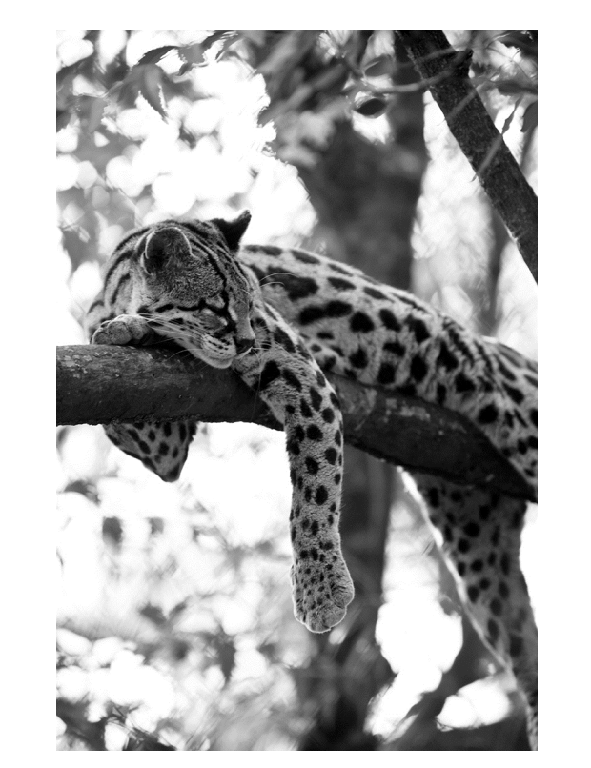

● excretion
● growth
● digestion
● respiration
How many of the processes that occur in the margay are characteristics of all living organisms?
A 1
B 2
C 3
D 4
Answer: ________

2. Part of the base sequence of DNA from four species was determined.
species 1 T C A G G A T T
species 2 T G A G C A A T
species 3 T G A G C A A G
species 4 T G A G G A T T
Which two species are the least closely related?
A 1 and 2
B 1 and 3
C 2 and 4
D 3 and 4
Answer: ________

3. A single-celled organism has chloroplasts, a cell wall and a nucleus. Which kingdom is this organism placed in?
A fungus
B plant
C prokaryote
D protoctist
Answer: ________

4. What is a leaf?
A a cell
B an organ
C an organ system
D a tissue
Answer: ________

5. A student measured the length of a structure using a microscope. The magnification used was 250. The image size of the structure was 5.00 mm. What was the actual length of the structure?
A 1.25 x10³ mm
B 1.25 x10³ μm
C 2.00 x10¹ μm
D 2.00 x10⁻⁵μm
Answer: ________

6. 1 In which parts of the digestive system does physical digestion occur?

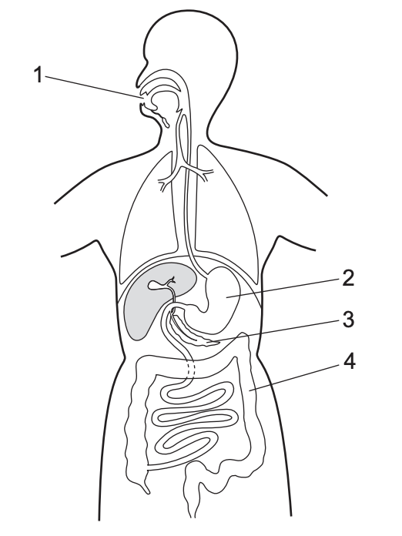
A 1, 2 and 3
B 1 and 2 only
C 2 and 3 only
D 4 only
Answer: ________

7. The table shows the substrates and end products in four enzyme-controlled chemical reactions. Which reaction was controlled by lipase?
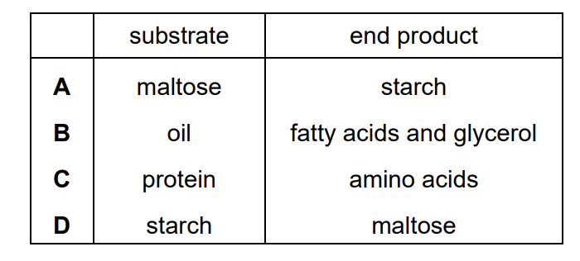
Answer: ________

8. What is the function of microvilli in the small intestine?

A conduction of electrical impulses
B increasing surface area for absorption
C movement of food particles
D movement of mucus
Answer: ________

9. A student wanted to investigate the effect of humidity on transpiration. She set up two sets of apparatus with identical-sized plants of the same species.
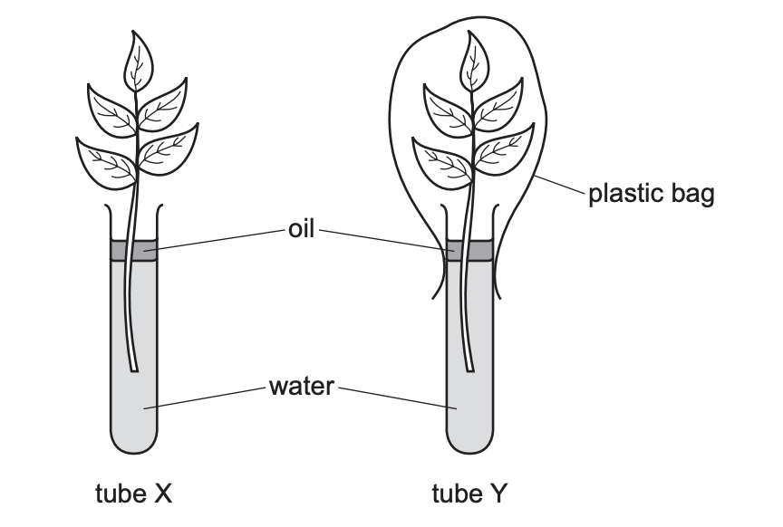
The masses of the water in both tubes were measured at the start of the investigation and again after five days. The table shows the results of the investigation.
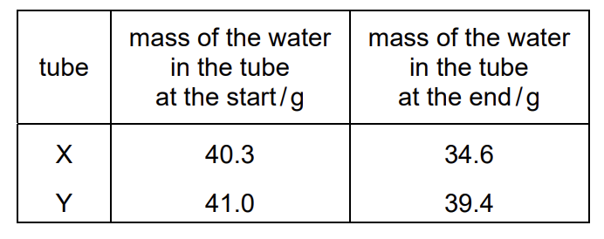
Which statement describes and explains these results?
A Transpiration in tube Y was higher than in tube X as the plastic bag decreased the humidity.
B Transpiration in tube Y was higher than in tube X as the plastic bag increased the humidity.
C Transpiration in tube Y was lower than in tube X as the plastic bag decreased the humidity.
D Transpiration in tube Y was lower than in tube X as the plastic bag increased the humidity.
Answer: ________

10. The diagram shows a vertical section through part of a human eye. A fly is coming nearer to the eye. The eye begins to focus the image of the fly on the retina.
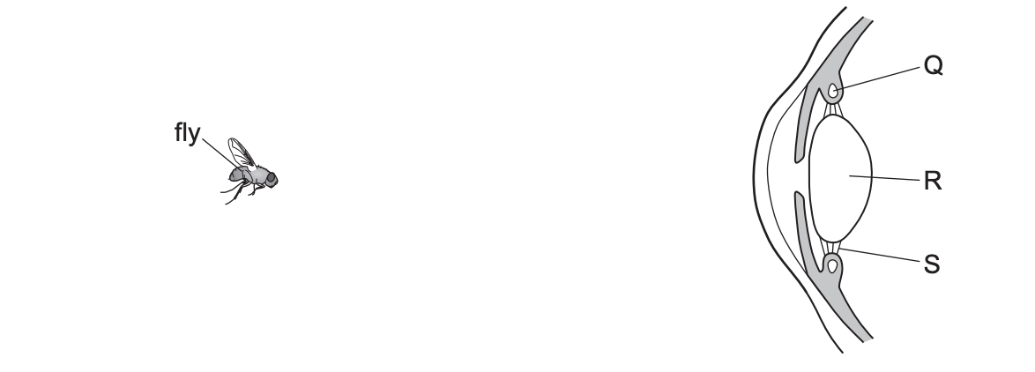
How do the labelled parts of the diagram change?
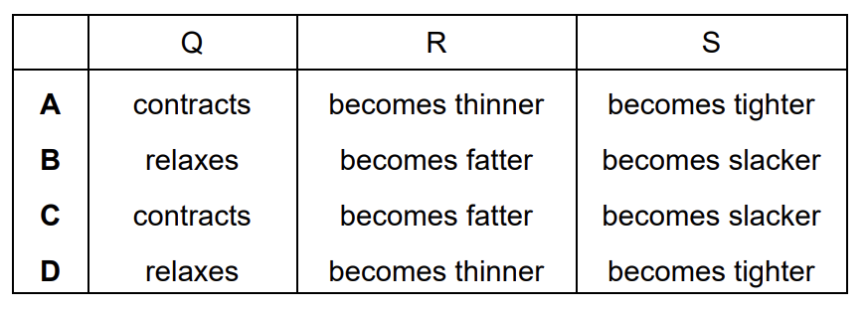
Answer: ________

11. Clostridium difficile is a species of bacterium that is resistant to many antibiotics. From 2002 to 2006, the number of people in one country infected with Clostridium difficile increased from 1300 to 6200 people. What was the percentage increase in the number of people infected with Clostridium difficile from 2002 to 2006 to the nearest whole number?
A 21%
B 27%
C 79%
D 377%
Answer: ________

12. The diagram shows the inheritance of a genetic condition in one family.
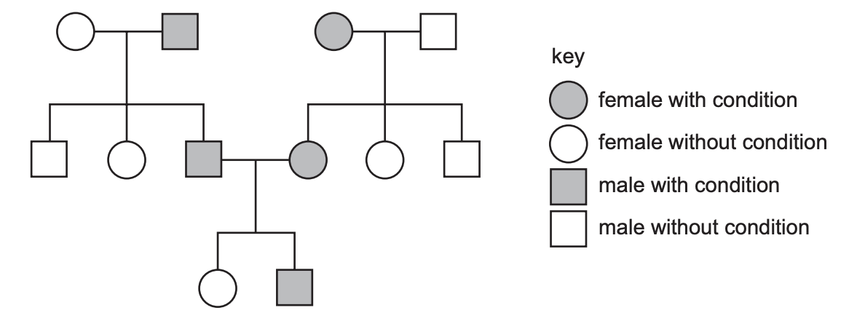
What can be concluded about this genetic condition?
A The alleles for the condition must be codominant.
B It is caused by a dominant allele.
C It is caused by recessive alleles.
D The alleles for the condition must be sex-linked.
Answer: ________

13. The diagram shows part of the nitrogen cycle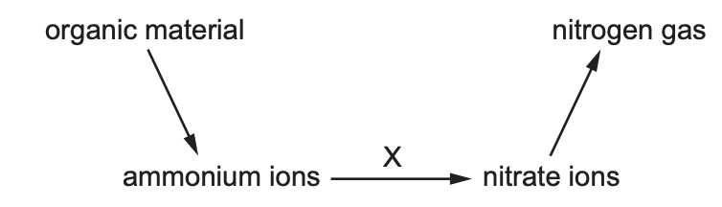.
What is the process labelled X in the diagram?
A decomposition
B denitrification
C nitrification
D nitrogen fixation
Answer: ________

14. When managing fish stocks as a sustainable resource, what is a reason for harvesting only the larger fish of a particular species?

A Larger fish are easier to harvest.
B Larger fish sell at a higher price.
C Smaller fish are eaten by predators.
D Smaller fish are too young to breed.
Answer: ________

15. Which features make bacteria useful in biotechnology?
1 They are unaffected by antibiotics.
2 They do not contain plasmids.
3 They make complex molecules.
4 They reproduce rapidly.

A 1 and 2
B 1 and 4
C 2 and 3
D 3 and 4
Answer: ________

Answer following questions
1. Fig. 2.1 is a photomicrograph of human blood.
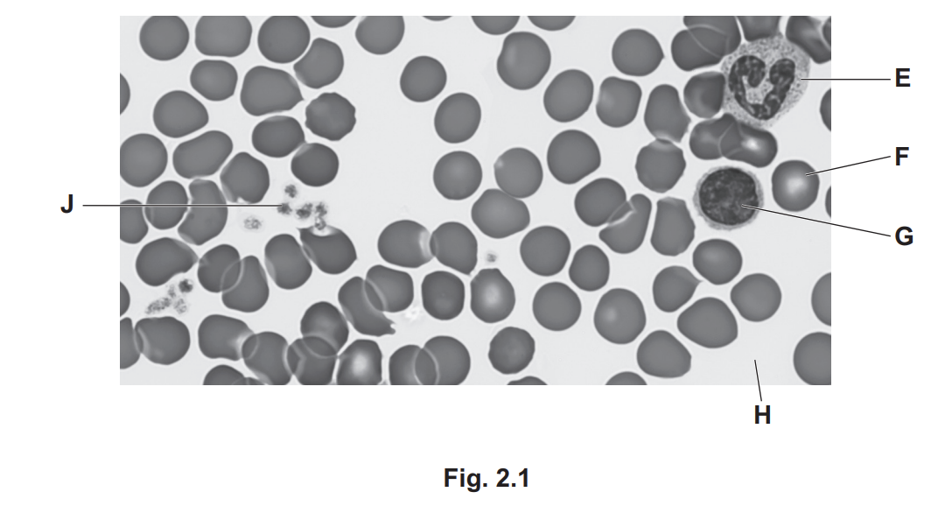
(a) Use the information in Fig. 2.1 to complete Table 2.1.
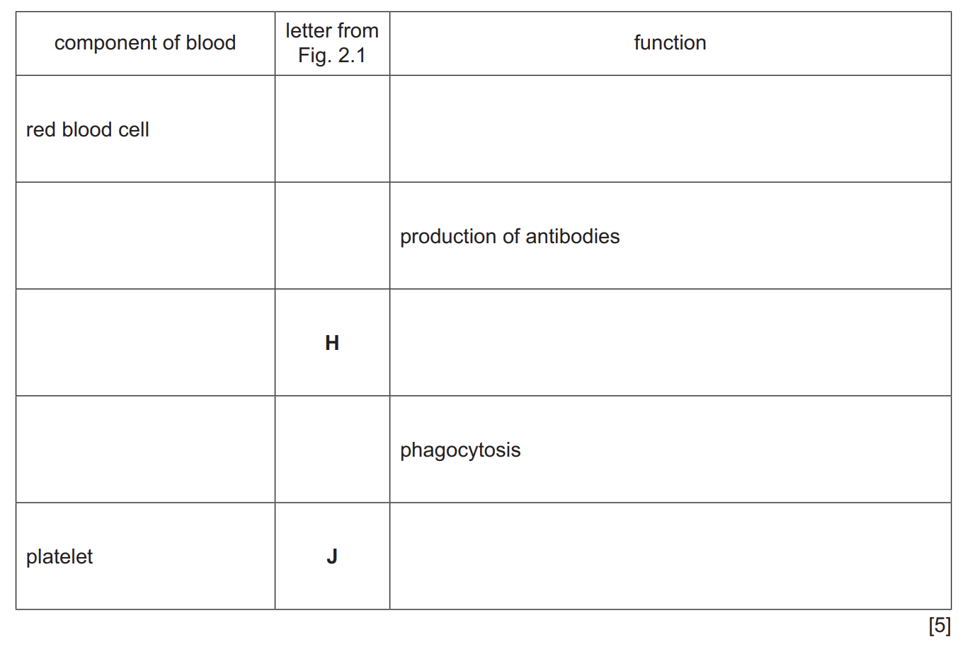
Answer:
Red blood cell_______ _______________
_____________ ______ production of antibodies
_____________ H ____________________
_____________ ______ phagocytosis
Platelet J _____________________

(b) Some diseases are transmissible.
(i) State the name of a pathogen that is transmitted by direct contact with blood. ..................................................................................................................................... [1]
(ii) State two ways that a pathogen can be transmitted indirectly.
1 ........................................................................................................................................
2 ........................................................................................................................................ [2]
(c) Describe the role of antibodies in the defence against pathogens. ................................................................................................................................................... ................................................................................................................................................... ................................................................................................................................................... ................................................................................................................................................... ................................................................................................................................................... ................................................................................................................................................... ............................................................................................................................................. [3]

(d) Explain how active immunity differs from passive immunity. ................................................................................................................................................... ................................................................................................................................................... ................................................................................................................................................... ................................................................................................................................................... ................................................................................................................................................... ................................................................................................................................................... ............................................................................................................................................. [3]

2. Scientists developed genetically modified (GM) maize. Fig. 3.1 shows the mass of GM maize grown in one country from 2000 to 2015.

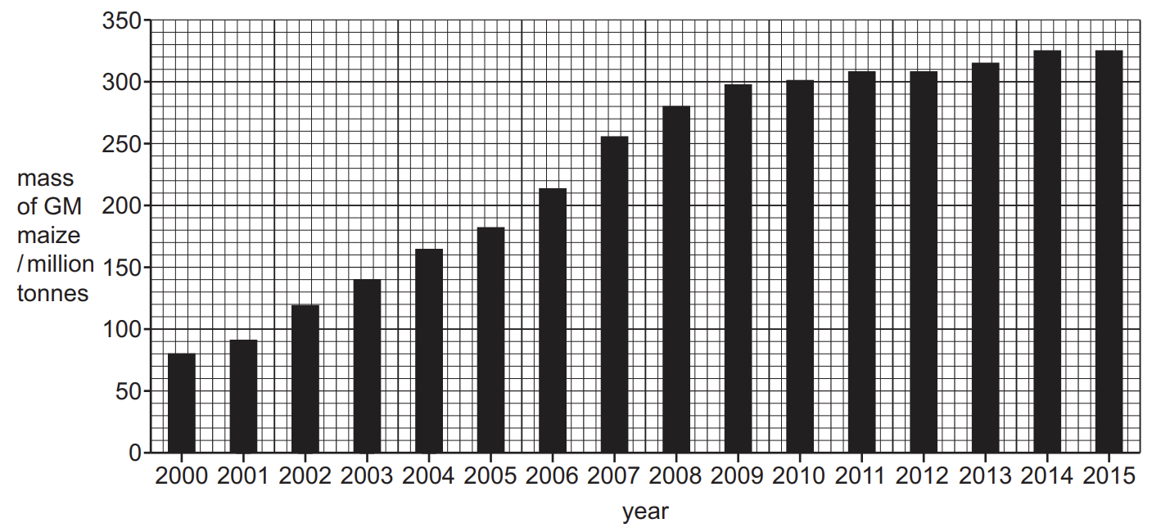
(a) Calculate the percentage increase in the mass of GM maize grown between 2000 and 2015. Give your answer to two significant figures.
Space for working.

...................................................... % [3]

3. Fig. 5.1 is a diagram of a plant root hair cell.
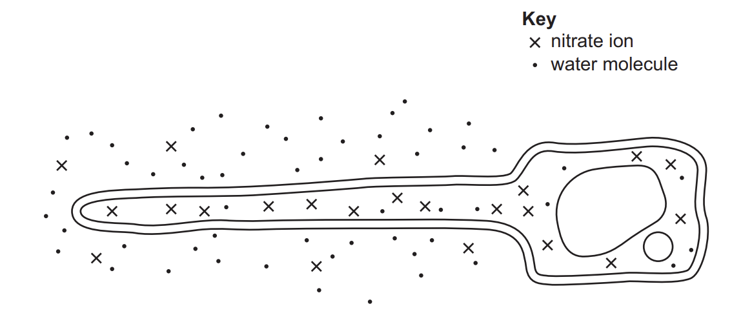
(a) (i) Using the information in Fig. 5.1, explain how nitrate ions are transported into the root hair cell. ........................................................................................................................................... ........................................................................................................................................... ........................................................................................................................................... ........................................................................................................................................... ........................................................................................................................................... ........................................................................................................................................... ........................................................................................................................................... ........................................................................................................................................... ..................................................................................................................................... [4]
(ii) State two ways that nitrogen fixation occurs.
1 ........................................................................................................................................
2 ........................................................................................................................................ [1]

(b) State the name of the process that moves water molecules into root hair cells. ............................................................................................................................................. [1]
(c) Describe differences and similarities between the structure of a plant root hair cell and a bacterial cell. ................................................................................................................................................... ................................................................................................................................................... ................................................................................................................................................... ................................................................................................................................................... ................................................................................................................................................... ................................................................................................................................................... ................................................................................................................................................... ................................................................................................................................................... ................................................................................................................................................... ................................................................................................................................................... ............................................................................................................................................. [5]

